Volleyball - Intermediate

Basic Positions
- Power – blocks and attacks on the outsides
- Middle – blocks and attacks in the middle
- Setter – sets the ball
- Libero – a back-row-only player that is a defensive specialist

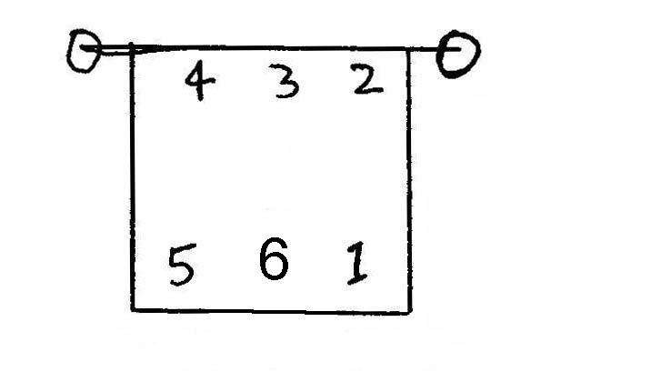
Court Numbering
- Each place on the court has a designated number as follows:

Skills

- Volleys – fingers firm, hands form the shape of the ball, contact just in front of the forehead, extend arms and wrists (like a basketball chest pass going upwards)
Tip: square your shoulders to where you want to volley the ball

- Bumps (Pass) – shrug shoulders and squeeze arms together, arms straight out in front, bend at the waist, “push” and/or lean towards the direction you want the ball to travel
Tip: think of your arms as a wooden board, bumping is simply deflecting the ball to where you want it to go, so making the correct angle with your arms is critical

- Overhead Float Serve – feet close together, hold ball straight out with non-hitting arm, hitting arm pulls behind head, toss ball straight up, step with opposite foot and hit the ball with the palm of the hitting arm, do not snap the wrist – it is called a float serve because the ball should not spin Tip: stare at the ball and aim dead center as you hit it

- Spikes – start from just behind the attack line, take 2 big steps for your approach then jump, (as you jump,) swing your arms to get more height, throw your hands up towards the ball, pull your hitting arm back, and snap your wrist as you hit the ball with your entire hand (this creates topspin) Tip: focus on timing your jump, the hitting part will improve dramatically.

- Tips – jump as if hitting a hard spike, gently guide the ball with the fingers

- Blocking – stand almost at an arm’s length from the net, jump a split second after the hitter jumps, reach over the net as far as you can with your hands, with fingers spread out, tighten up your body to get some “attitude” in your block
Tip: blocking is 50% technique/timing, and 50% attitude!

Strategies

- “W” Service Formation – is a way of receiving serve.
Front row: the middle player moves up to the net, the other two players receive short serves
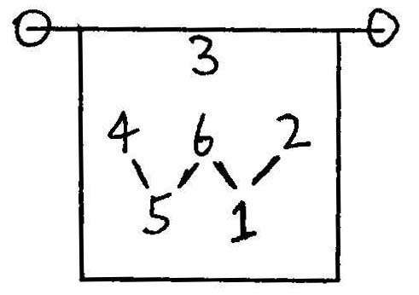
Back row: the middle player moves up to receive short serves, the other two players receive all the deep serves

- Switching – players may switch places as soon as the ball is served, just make sure you don’t cross with the players that are adjacent to you (before the serve)
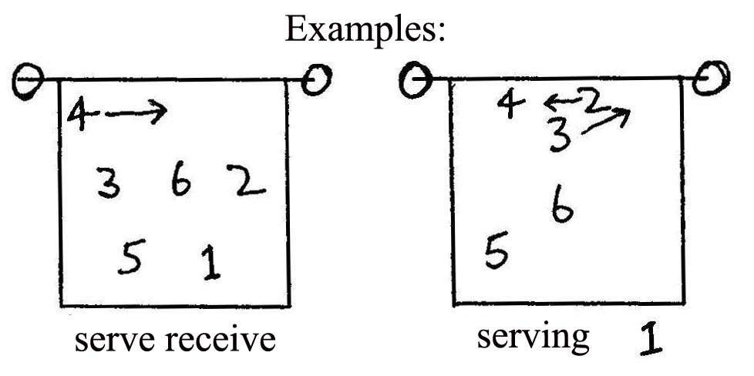

Offence and Defense

- 4 – 2 Offence (middle setter) – means that there are 4 hitters and 2 setters in this offensive formation, and that the setter sets from the middle (because the setter sets from the middle, there is no Middle position)

- 6 – Up Defence – a good way of defending your court when using a 4-2 offence. Back row: the middle player moves up to cover tips, the other two players cover deep. Front row players block.
