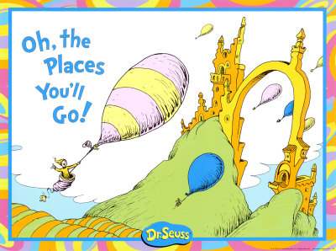
What is your life story/journey going to look like? Best place to start on your journey into the future is to look at where you come from. Hard to predict future, but much of who you are and what you think has already been set.

Purpose of assignment: to familiarize yourself with PowerPoint and be able to successfully create a professional presentation.
Requirements for the presentation:
- You must have one slide for the title.
- You must have at least 10 slides. You may use more if you want (no more than 15 slides).
- You should apply a template to your presentation. Choose one you like.
- Add clip art, photos, music and videos to some of your slides. Be conservative with this as too much on a slide can make the presentation too busy.
- Point form and no more than 7 words per line.
- Add animation and transitions to your slides.

​Items to include in your presentation (you could also add your own):
- Information about yourself: age, where you were born (hospital, place), where you go to school, etc.
- Your family
- Your interests
- Your hobbies
- Your favorite memory
- Your favorite movie, book, food, song, colour, animals etc.
- Your pets
- The best thing about school
- What you want to do when your grow up
- Who you would like to meet: alive or passed away
- Your favorite quote
- Your role model

