

Graphing is an important procedure used by scientist to display the data that is collected during a controlled experiment. There are three main types of graphs:

Pie/circle graphs: Used to show _________________.

Bar graphs: Used to compare __________________.

Line graphs: Use to show the change of one piece of information as it __________ to another change.

“____________________________________”

Both bar and line graphs have an “X” axis (_______________) and a “Y” axis (_________________).

**Parts of a Graph**:

**Title:** Summarizes information being represented in ANY graph.

**Independent Variable:** The variable that is controlled by the experimenter, such as, time, dates,

depth, and temperature. This is placed on the **________________**.

**Dependent Variable:** The variable that is directly affected by the I.V. It is the result of what

happens as time, dates, depth and temperature are changed. This is placed on the **______________**.

**Scales for each Variable:** In constructing a graph, one needs to know where to plot the points representing the data. In order to do this a scale must be employed to include all the data points. This must also take up a conservative amount of space. It is not suggested to have a run on scale making the graph too hard to manage. The scales should start with 0 and climb in intervals such as, multiples of 2, 5, 10, 20, 25, etc…the scale of numbers will be determined by your data values.

**Legend:** A short descriptive narrative concerning the graph’s data. It should be short and concise

and placed under the graph.

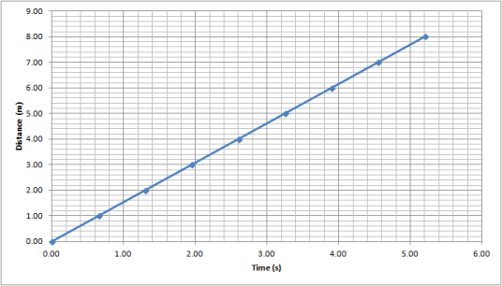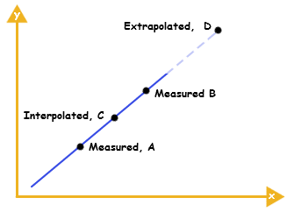

**Extrapolate:** ____________ the graph, along the same slope, above or below measured data.

**Interpolate:** predicting data ______________ two measured points on the graph

*B. Graph the following information in a* ***BAR graph****. Label and number the x and y-axis appropriately.*

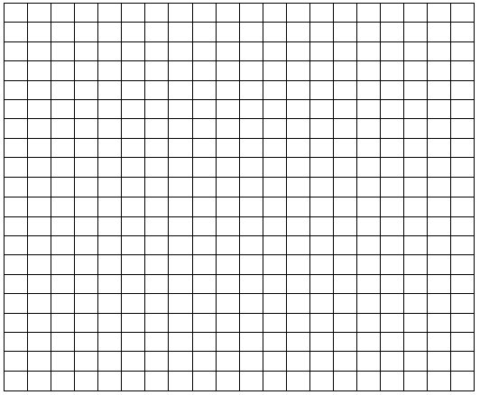

|  |  |
| --- | --- |
| **Month** | **# of deer** |
| Sept | 38 |
| Oct | 32 |
| Nov | 26 |
| Dec | 20 |
| Jan | 15 |
| Feb | 12 |

1. What is the independent variable?

2. What is the dependent variable?

3. What is an appropriate title?

4. What is the average number of deer per month?

***Try:*** *Graph the following information in a* ***BAR graph****. Label and number the x and y-axis appropriately.*



|  |  |
| --- | --- |
| **Type of Insect** | **Vibration Rate (beats per second)** |
| Mosquito | 760 |
| Honeybee | 440 |
| House Fly | 350 |
| Beetle | 220 |

Note: Hummingbird are only 80 beats/s

1. What is the independent variable? ________ ______

2. What is the dependent variable? ________

3. What is an appropriate title?

*C. Graph the following information in a* ***LINE graph****. Label and number the x and y-axis appropriately.*



|  |  |
| --- | --- |
| **Volume of water in soil (mL)** | **# of Earthworms** |
| 0 | 3 |
| 10 | 4 |
| 20 | 5 |
| 30 | 9 |
| 40 | 22 |

1. What is the independent variable?

2. What is the dependent variable?

3. What is an appropriate title?

***Try*** *Graph the following information in a* ***LINE graph****. Label and number the x and y-axis appropriately.*



Space Shuttle Launches

|  |  |
| --- | --- |
| **Time**  **(s)** | **Velocity (m/s)** |
| 0 | 0 |
| 5 | 2 |
| 10 | 4 |
| 15 | 6 |
| 20 | 8 |
| 25 | 10 |
| 30 | 12 |
| 35 | 14 |

1. What is the independent variable?

2. What is the dependent variable?

3. What is an appropriate title?