Purpose: To construct a paper airplane(s) and use the scientific method to perform an experiment with it.

Discuss the following questions with your partner…..
- Have you made and flown a paper airplane before?
- Do you always use the same type of paper?
- Do you always use the same design?
- Do you want it to fly straight or do tricks?
- Do you add other materials to your plane?

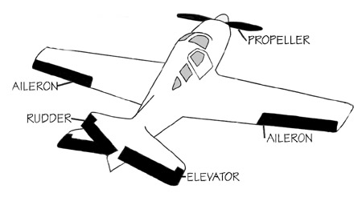
Here are questions you may want to consider when thinking about an experiment on your plane...

- How does adding paper clips to a paper airplane affect its flight?
- How does a change in type of paper affect its flight?
- Do ailerons, elevators, or rudders affect its flight?
Choose one or come up with your own question

Questions: ____________________________________________________________________ ______________________________________________________________________________

Hypothesis
What do you think is going to happen if………
- How do you think the addition of a paper clip to the paper airplane affects its flight distance?
- Does the placement of the clip matter?
Example:
If a paper clip is added to this _(location)_ of the paper airplane, then ________ will happen.

Hypothesis: ___________________________________________________________________ ______________________________________________________________________________

Materials - What do you need to perform this experiment?
List of materials:

Procedure - This should be written as a list of numbered steps. Each step must be clear AND concise.
Example
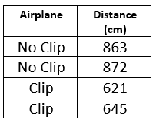
- Make the "Dashing Dart" paper airplane. See instructions from book pages 46-47.
- Gather materials and head out to your assigned runway.
- Fly your initial airplane, measure the flight distance, time, speed or trick…, and record your data in as table.
- Make ONLY ONE change to your airplane.
- Fly your airplane, measure the flight distance, time, speed or trick…, and record your data in a table.

Procedures: Data

Conclusion – Written explanations for the experiment that relates to what you observed and the results you obtained. Do not repeat the procedure OR the hypothesis and should only 3-4 sentences long.
Guiding Questions:
- Was your hypothesis correct? Explain why or why not?
- Is there anything that you would have or should have done differently?
- What are some things you learned in this activity?

