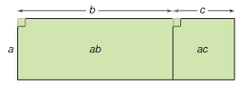
Distributive Property
a(b+c) = ab + ac
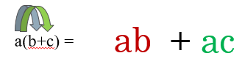
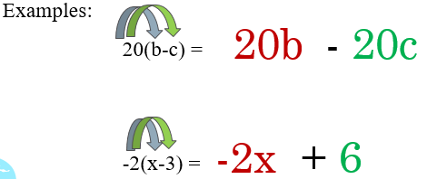

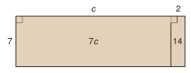
Use Distributive property
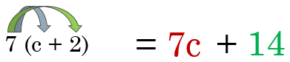

Use Distributive property to expand and solve
6 (x + 10) = 120
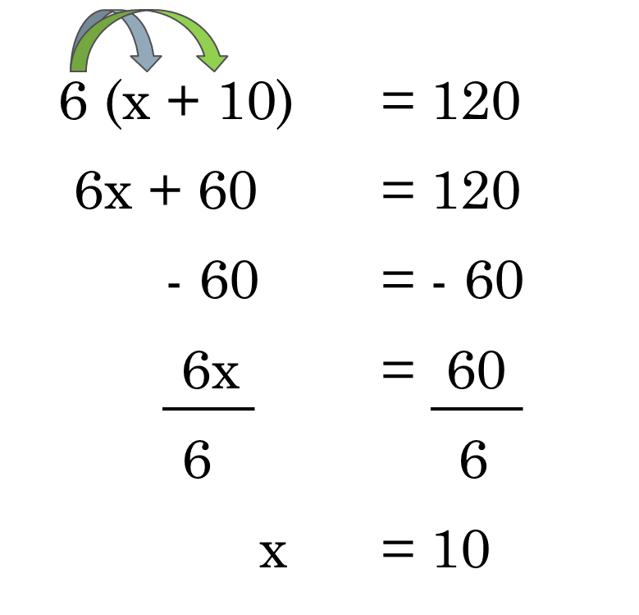

Bob thought of his favourite number. He then subtracted two. Then multiplied the difference by 5. The product was 60. Write an equation to problem. What was Bob favourite number?
5(b -2) = 60
5b – 10 = 60
5b = 50
b = 10

John and Lorraine are landscaping their yard. They are buying pyramidal cedars that cost $12 each. John and Loraine need 11 cedars to shade their patio at the end of the yard. They would like to purchase as many more cedars for the adjacent sides. They have $336 to buy cedars. How many more cedars can they buy. Write an equations that models this problem to help determine the number of cedars.
12(t + 11) = 336
12t + 132 = 336
12t = 204
t = 17

