A time machine has been invented that travels into the past and takes pictures, sending them to the present. You are asked to look at one of the pictures and interpret what you see.

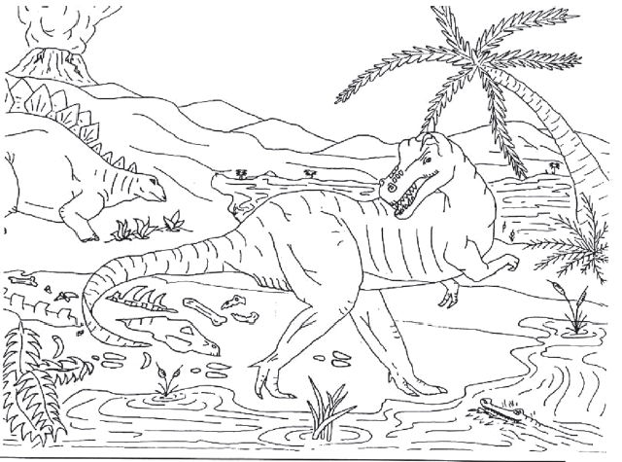

**Use either observation (O) or Inference (I) for the following:**

____ 1. The volcano is erupting.

____ 2. The camptosaurus is going to eat the stegosaurus.

____ 3. The stegosaurus will run into the water to escape.

____ 4. The camptosaurus is leaving tracks in the ground.

____ 5. The ground where the camptosaurus is walking is wet.

____ 6. There are plants growing in the water.

____ 7. The camptosaurus is going into the water to eat the plants.

____ 8. There is a tree growing next to the river.

____ 9. The tree looks like a palm tree.

____ 10. The climate is warm.

____ 11. The stegosaurus is eating the plant.

____ 12. The stegosaurus is an herbivore.

____ 13. There are bones from a dead animal by the shore.

____ 14. The camptosaurus killed the animal.

____ 15. Some more bones are in the water.

____ 16. The camptosaurus can’t swim and will drown.

____ 17. Lava is corning down the sides of the volcano.

____ 18. The camptosaurus has sharp teeth for eating meat.

Suppose you are a paleontologist and you have just discovered a layer of rock with many fossils in it, both petrified bones and tracks.



Decide whether the following statements are observations or inferences.

A. Observation B. Inference

19. ___**_**_ There are tracks from three different animals in the rock.

20. _**___**_ One animal was chasing another animal.

21 _**__**__ Two different animals died in this spot.

22. _**__**__ When the animals walked here the ground was wet.

23. _**__**__ One of the animals that died here had bony plates.

24. _**___**_ One of the animals that died here had sharp teeth.

25. _**___**_ The animal that had sharp teeth ate meat.

**Qualitative Observations vs. Quantitative Observations**

All of the observations in this worksheet were qualitative; that is, you observed a quality about an object (it smelled good, it was green, etc.). Another type of observation is quantitative, meaning that it can be described or measured in concrete numerical terms.

* The following observations are quantitative: There are 30 students in my class. I weigh 98 pounds. I ate a pound of potatoes.

Determine which of the following statements are quantitative and which are qualitative

_____1. The cup had a mass of 454 grams. ____2. The temperature outside is 250o C.

__**__**_3. It is warm outside. __**_**_4. The tree is 30 feet tall.

__**__**_5. The building has 25 stories. __**_**_6. The building is taller than the tree.

__**_**__7. The sidewalk is long. __**_**_8. The sidewalk is 100 meters long.

__**__**_9. The race was over quickly. __**_**_10. The race was over in 10 minutes

In each of the following, make an observation, prediction and inference about each picture

Observation: _____________________________

________________________________________

________________________________________

Prediction: _______________________________

________________________________________

________________________________________

Inference: _______________________________

________________________________________

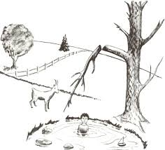________________________________________

Observation: _____________________________

________________________________________

________________________________________

Prediction: _______________________________

________________________________________

________________________________________

Inference: _______________________________

________________________________________

________________________________________

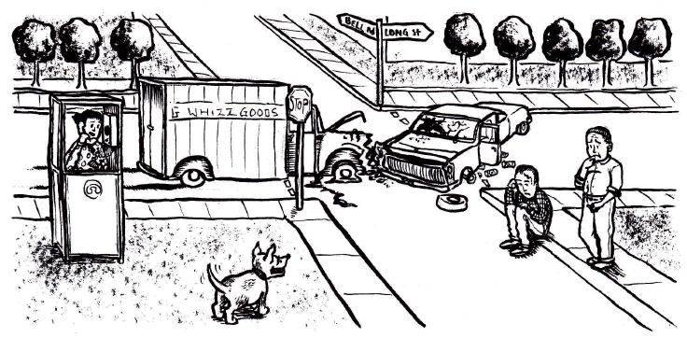

Observation: _____________________________

________________________________________

________________________________________

Prediction: _______________________________

________________________________________

________________________________________

Inference: _______________________________

________________________________________

________________________________________