Recall: Order of Operation (BEDMAS)
- Evaluate expressions within brackets.
- Evaluate all exponents.
- Multiply and divide from left to right.
- Add and subtract from left to right.

Try to Solve: (2+3) x 5 – 2 x (10 ÷ 2+3)
5 x 5 - 2 x 8
25 - 16
9

Building Expressions and Undoing an Equation
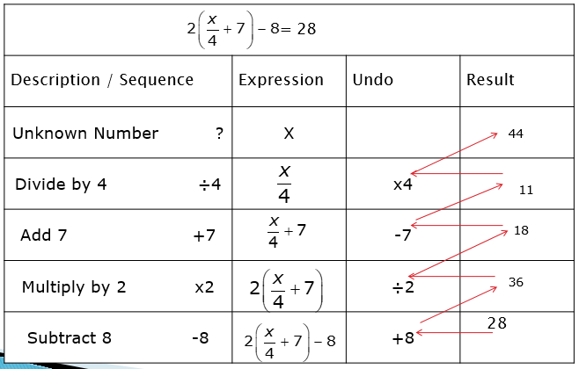

Building Expressions and Undoing an Equation
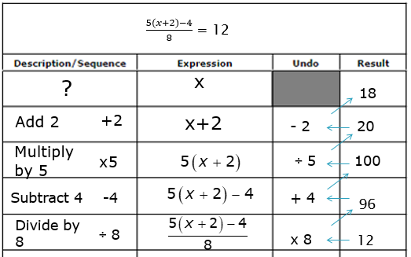
Using Algebra to Solve Equations
Note: Need to isolate the variable term & What ever you do to the left side of the equal sign, you must do to the same to the right side

Find the solution to the equation: 5b + 15 = -5
- Subtract 15 to each side -15 = -15
5b = -20
- Divide each side by 5 5 = 5
b = -4

- Verify the solution: 5(-4) + 15 = -5
-20 + 15 = -5
- 5 = -5 Left Side equal Right Side, therefore
Solution is correct

Find the solution to the equation: 16t - 77 = -13
- Add 77 to each side +77 = +77
16t = 56
- Divide each side by 16 16 = 16
b = 4

- Verify the solution: 16( 4 ) - 77 = -13
64 - 77 = -13
- 13 = -13 Left Side equal Right Side, therefore
Solution is correct
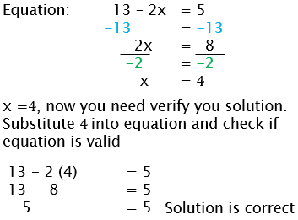
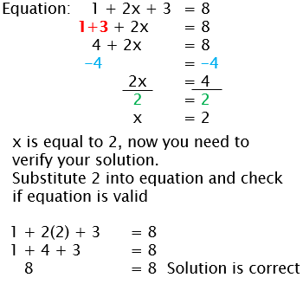
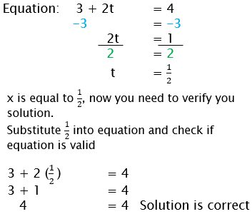
Practice: 13 – 2x = 5 3 + 2t = 4 1 + 2x + 3 = 8

Verify:

