- Vision Test - Snellen Eye Chart
1. Place the chart on a wall 20 feet (6 meters) away.
2. Cover one eye with your hand such that you completely the covered eye. (Do not apply pressure to the covered eye, as it might affect that eye’s vision when you test it.)
3. Identify a line on the chart you can comfortably read. Read the letters on that line aloud. Have your assistant stand near the chart and record your accuracy.
4. Continue trying to read the letters on each successively smaller line. Do not squint.
5. Have your assistant stop you when you fail to correctly identify at least 50 percent of the letters on a line.
6. Switch to the other eye and repeat.

Record your visual acuity for each eye by noting the line for which you correctly identified either: a) More than half the letters on that line, but not all of them.
b) All letters on that line, plus a few letters (less than half) on the next line.

Ex. If you correctly identify five of the seven letters on line 6, your visual acuity for that eye is: 20/30 or 6/9. If you correctly identify all seven letters on line 6 and three of the eight letters on line 7, your visual acuity in that eye is: 20/30^{+3/7}

- What was your visual acuity?
Left Eye: ___________________________________
Right Eye:

- Was you vision normal? Explain using 20/20 or 6/6 format.

- Colour-Blindness Tests

- Go to http://www.toledo-bend.com/colorblind/Ishihara.asp

Record what you see in the chart below. Don't peak at the answers near the bottom of webpage!

 | Left | Right
Top
Middle
Bottom

This test was to see if you are __________________ color blind.

- Go to http://enchroma.com/test/instructions/

Now TEST YOUR COLOR VISION with this online test!
Record you results: ____________________________________________________________
- Answer the following questions:
- What type of glasses (lens) do you need for people with Myopia and Hyperopia? Explain how this lens improves vision.

- What risks are involved when getting corrective laser eye surgery?

- How do red-and-blue 3D glass work?

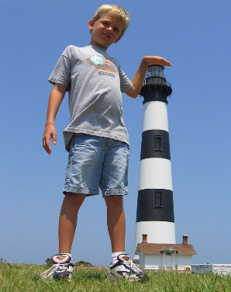
- Forced perspective is a technique which uses optical illusion to make an object appear farther away, closer, larger or smaller than it actually is. It manipulates human visual perception through the use of scaled objects and the relationship between them and the vantage point of the camera.

Your assignment:
With a partner you will create your own forced perspective picture. Marking will be based on creativity, appropriate use forced perspective, and clarity of photo. Labeled photos are to be submitted to the class I drive.

Criteria | Fully Meeting Expectations | Meeting Expectation | Minimally Meeting Expectations | Not Yet Meeting Expectations
Creativity | Original idea |  |  | Seen before
Correct Technique | Correct alignment |  |  | Not to scale
Clarity of photo | Clear, sharp |  |  | Out of focus

