Label the diagram using the bold words in the paragraph below, then colour it red where oxygenated blood is and blue where deoxygenated blood is. Use the paragraph and the picture on page 84 of your textbook to help you.

The heart is a fist-sized, muscular organ that pumps blood through the body. 1. Deoxygenated blood enters the right atrium of the heart via veins called the inferior vena cava and the superior vena cava (superior means “above” and inferior means “below”). 2. The blood is then pumped to the right ventricle and then through the 3. pulmonary artery (label twice) to the lungs, where it is enriched with oxygen and loses carbon dioxide. 4. The oxygenated blood is then carried back from the lungs to the heart by the pulmonary veins (label twice) and enters the 5. left atrium. The blood is then pumped to the 6. left ventricle, then through the 7. aorta to the rest of the body's cells. This cycle is then repeated.

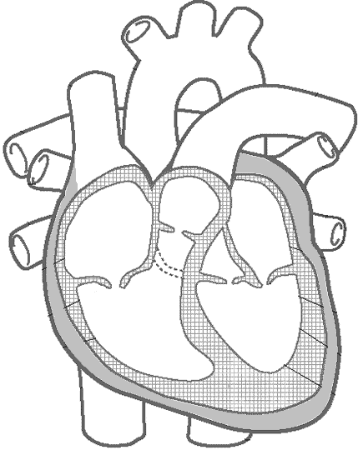

Right Atrium

