Ordered Pairs/Coordinate Pairs/Coordinates

Two numbers written in a certain order usually written in parenthesis
- used to show the position on a graph

Plotting Points
- when we plot a point, we always start at the origin (0,0)

  - If x is positive, move right
  - If x is negative, move left
Positive
Negative
(0,0)
y - axis
- 4 quadrants (I, II, III, IV)
I
IV
  - If y is positive, move up
  - If y is negative, move down

Coordinate Grid/Cartesian Plane

- 4 quadrants (I, II, III, IV)
- x-axis runs horizontally through the origin (0,0)
- y-axis runs vertically through the origin (0,0)
y - axis
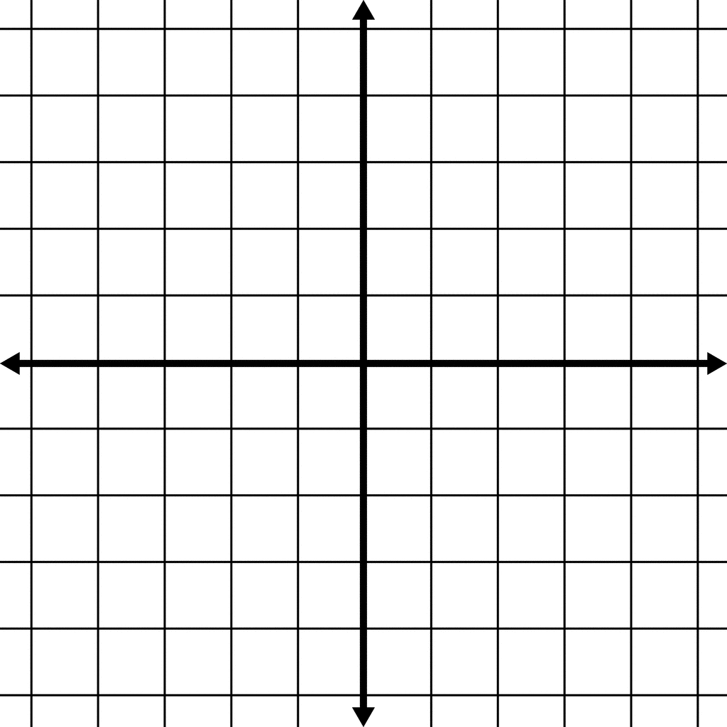
x - axis
(0,0)
IV
III
II
I

