

**Identify 6 different safety concerns shown in the picture below**

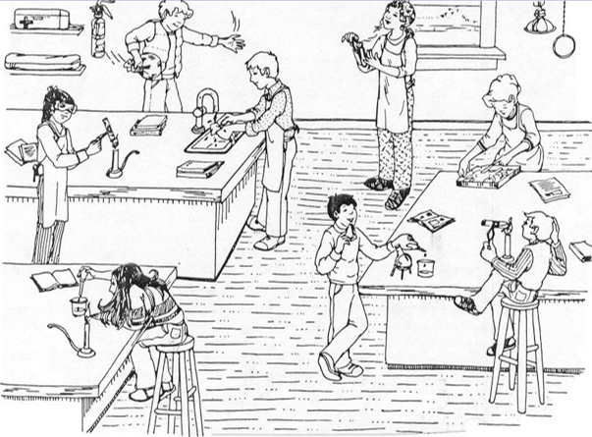

MCj03499660000[1]**General Safety Rules**

1. Listen to or read all instructions always
2. Wear safety goggles at all times while in the lab
3. Notify your teacher if any spills or accidents occur
4. Wash your hands after handling chemicals
5. Tie back long hair
6. Know the location of the fire extinguisher, fire blanket, eyewash station, and first aid kit
7. Keep your work area uncluttered
8. Never eat, drink, or chew gum in the lab.
9. MCHM00372_0000[1]Clean up your lab area at the end of the laboratory period.
10. Never “horse around” or play practical jokes in the laboratory

**Glassware Safety**

1. Chipped or cracked glassware should not be used and is disposed in a special glass container
2. Pour down a glass stirring rod to prevent liquids from splattering.
3. Do not place hot glassware in water, it may shatter.

**Chemical Safety**

1. MCHM00150_0000[1]If you need to smell the odor of a chemical, waft the fumes toward your nose with one hand. Do not put your nose over the container and inhale the fumes
2. Never mix chemicals together unless you are told to do so
3. Never taste any chemicals
4. Never pour water into an acid. Acid should be poured slowly into water
5. ****Follow teacher direction of disposing material

**Heating Safety**

1. Use tongs and/or protective gloves to handle hot objects.
2. When lighting a burner, wait until a match is struck or the striker is in place before you turn on the gas.
3. Never reach across an open flame or burner.
4. When heating a test tube, move it around slowly over the flame to distribute the heat evenly.
5. Always point the top ends of test tubes that are being heated away from people.
6. Test if hot plate is cool by bringing the back of your hand close to it.

**First Aid**

**Injury: Burns**

**To do:** Immediately flush with cold water until burning sensation is lessened.

**Injury: The eyes**

**To do:** Flush eyes immediately with plenty of water for several minutes. If a foreign object is lodged in the eye, do not allow the eye to be rubbed.

**Identify 9 different safety concerns shown in the picture below**

