Label the eye parts AND THEN colour your diagram.
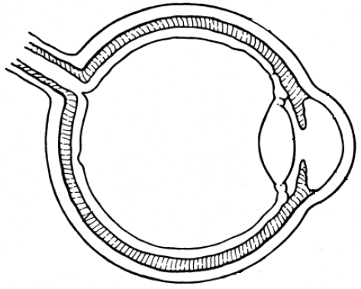
________: tough, opaque cover that forms the “white” of the eye and helps to keep its shape
__________: carries nerve signals from the retina to the brain
_____________: gel-like substance that fills the space between the lens and the retina, giving the eye its shape
__________: area where the image is produced and converted into nerve signals
__________: layer of blood vessels between the retina and sclera that supplies blood to the retina
_______________: control the thickness of the lens to adjust for near and far objects
________: changes shape to help focus light on the retina; convex
_____________: colourless, transparent covering that helps focus light on the retina
_____________: hole in the iris that light passes through to reach the retina
______________: water-like fluid between the cornea and the lens that provides oxygen and nutrients and gives the front of the eye its shape
______: coloured circle of muscle surrounding the pupil that changes the size of the pupil

Compare & Label the parts of the Eye to the parts of a camera

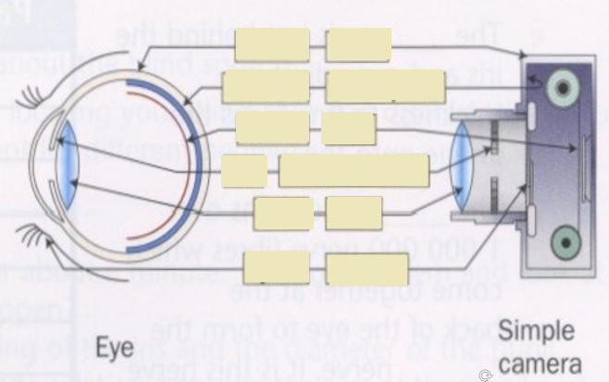

What part of the eye would the aperture, opening for light to enter, be _________________

What part of the eye would the Focus Control, moves the lens system farther or closer to the film, be _________________

What parts of the eye would the Lens system, sometimes several, be _________________, _______________, _______________, ______________.

