***Visible Parts of the Eye***

**Pupil -** the hole in the iris that light passes through to reach the retina

* The pupil appears dark because light passes through it without reflecting back

**Iris -** the coloured circle of muscle surrounding the pupil that changes the size of the pupil

* The iris is what we refer to when we speak of the colour of someone’s eyes

**Sclera** - the tough, opaque cover of the eyeball that forms the “white” of the eye and helps it keep its shape

* There are six muscles attached to the sclera that allow the eye to move up and down and side to side

**Cornea -** a colourless, transparent covering on the front of the eye that helps focus light on the retina. 80% of light refraction occurs here.

**Internal Parts of the Eye**

**Lens** – changes shape to help focus light on the retina

* Convex lens - the focusing of the image occurs here

**Aqueous Humor**

The water-like fluid between the cornea and the lens that provides oxygen and nutrients and gives the front of the eye its shape

**Ciliary Muscles** - control the thickness of the lens to adjust for near and far objects

**Vitreous Humor**

The gel-like substance that fills the space between the lens and the retina, giving the eye its shape

**Retina**

The area where the image is produced and converted into nerve signals from the retina to the brain

**Choroid (Coat) –** the layer of blood vessels between the retina and sclera that supplies blood to the retina

**Optic Nerve** - a thick nerve that carries nerve signals from the retina to the brain

***How Light Enters the Eye***

1. light passes through the cornea, which starts to refract light toward the retina
2. light then passes through the pupil
   * the iris changes shape to control how much light enters the pupil
   * in dim light, the iris expands (dilates) the pupil to allow more light to enter
   * in bright light, the iris shrinks (contracts) the pupil to reduce the amount of light entering
3. the light passes through the lens, whose shape is controlled by the ciliary muscles.
   * the light is refracted more and is then focused on the retina
4. cells in the retina convert the light rays into electrical signals that are sent to the brain via the optic nerve

**Producing an Image**

The image formed by the lens of your eye is inverted, but your brain interprets it as being upright

* Your eyes can focus on objects as close as 25 cm and as far away as you can see
* The ciliary muscles control the shape of the lens so that the refracted light is focused on the retina



* Light rays entering the eye are almost parallel and do not need to bend much to produce an image on the retina
* The ciliary muscles are relaxed and the lens is its normal shape (“thin”) because there is more tension on the lens



* Light rays from enter the eye at an angle, so must refract more than those from distant objects to produce an image on the retina
* 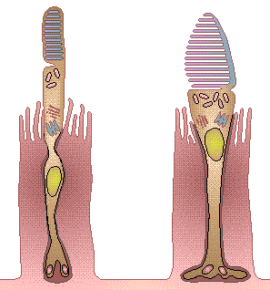The ciliary muscles contract, forcing the lens to become thicker (“fatter”) because there is less tension on the lens

There are two types of receptor cells on the retina, both named for their shape**:**

**Rods** - are sensitive to the level of light so that you can still see in low light conditions, like at night (black and white or shades of grey) - about 120 million of these in each eye

**Cones** -are sensitive to colour, so that you can see detail and colour of objects in brighter conditions

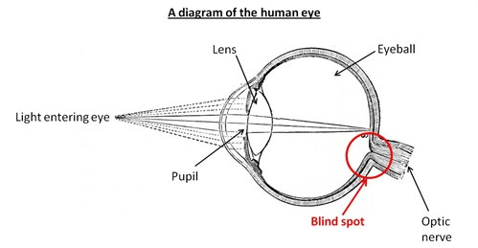 - about 6 million of these in each eye

**Blind spot** - Area in the eye where the optic nerve and blood vessels connect to the retina, and where there are no rods or cones

* If an image falls on the blind spot, you will not see it because there are no light receptor cells to send the signal to the brain
* Each eye sees what the other misses because the blind spots are not in the same place