Integers Foldable

- You are to design a foldable that has the titles on the front of each door labeled as: Addition, Subtraction, Division and Multiplication. You can use the example below or design your own.
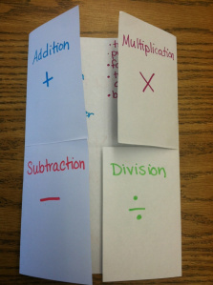
- You will put under the folds the rules to each operation and provide 2 different possible examples.
