Do the Values in a Table represent a Linear Relation
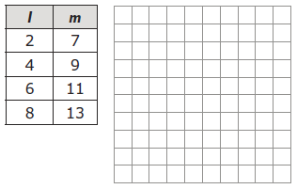
- Graph the ordered pairs in the table of values. Do these ordered pairs represent a linear relation? State two ways you would know if this table represents a linear relation.

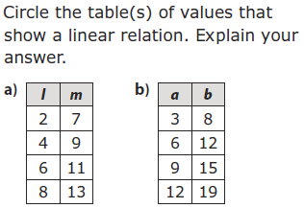

Writing Linear Expressions using a Table
- The following pattern of squares continues.

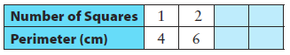
- Complete the following table. Is this a linear relation?

- Graph the table of values.

- What is an expression for the perimeter in terms of the number of squares?

- If the pattern continues, what is the perimeter when there are 50 squares?
- As you climb a mountain, the temperature drops 2 ºC for every 150 m of increased height.
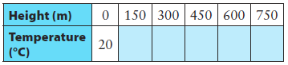
- Complete the following table.
Is this relationship linear?

- Write an expression for the temperature in terms of height.

- What is the temperature at 1000 m?

- Mara reads at a rate of 90 words per minute.

- Make a table of values that shows the total number of words Mara reads in 1 to 6 minutes. Use whole minutes.

- Graph the table of values.

- What is an expression for the number of words Mara can read in terms of time?

- How many words does Mara read in 12 minutes?

