Practice – Multiplying and Dividing Integers

1. Find each product.

a) (+6) x (–12) b) (–10) x (–4) c) (–8) x (–9)

d) (+11) x (+7) e) (–13) x (+5) f) (+12) x (–6)

2. Find each quotient.

a) (+8) ÷ (+4) b) (–9) ÷ (–3) c) (+36) ÷ (+12)

d) (–24) ÷ (–8) e) (+14) ÷ (–7) f) (–10) ÷ (+5)

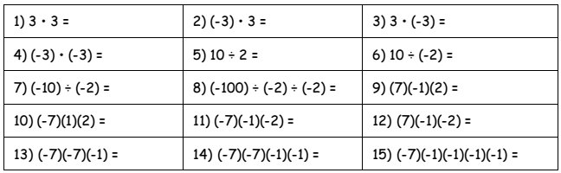
3. Find each product or quotient.

4. Represent each sentence with integers, and then find each product.

a) Gaston withdrew $26 from his bank account each week for 17 weeks. Find the total amount Gaston withdrew over the 17 weeks.

b) An old bucket has a small leak. Fifty-five milliliters (mL) of water leak out in 1 h. Find how much water leaks out in 6 h.

c) In math class, 15 people have highlighter pens. If each person has 3 highlighters each, how many highlighter pens in total can be found in the math class?

5. Represent each sentence with integers, and then find each quotient.

a) The temperature rose 3ºC each hour for a total change of +12ºC. Find the number of hours the change in temperature took.

b) A submarine was at the surface of the ocean. It made 4 identical plunges in a row. Its final depth was 148 m below sea level. What was the depth of each plunge?

c) Tyler decides that, starting this week, he will withdraw $5 from his savings account each week. How many weeks from now will Tyler have withdrawn $65.

6. Use the decoder below to determine how much each word is worth. Be sure to write the value of each letter and include the multiplication operation symbol and the answer.

