Expressions: a combination of letters and numbers and operations (+, -, x, ÷)
Ex 2b + 1 or 8 – 5g or -10x + 9

Variable: is the unknown in the expression
Ex. 3a – 5 the variable is the a

How do you know if a relation is linear?
- Look at the graph – does it create a straight line?
  - Do all the points move up/down and over left/right by the same amount?
  - If yes linear relation!
- Look at the table of values:
  - Do the “x” values go up by the same amounts?
  - Do the “y” values go up by the same amounts?
  - If yes to both linear relation!

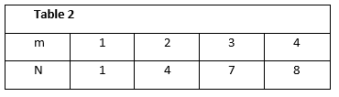
Example 1
Table 1
x | 2 | 4 | 6 | 8
y | 3 | 7 | 11 | 15

- Graph the table of values
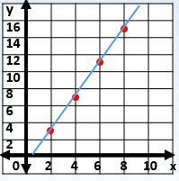
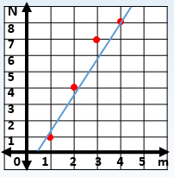

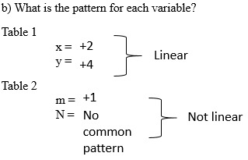

c) Which relations is linear?
Graph 1 is linear.
Graph 2 is not.

How to Write Expressions of linear relations…

If “x” and “y” have an ordered pair of zero (0,0):
- If the relation is linear, describe the relationship between “x” and “y”.
  - Look at the “x” value of 1. How many more times bigger/smaller is “y”?
- Write it as a multiplication to “x” #“x”

Example 1

“x” | “y”
0 | 0
1 | 4
2 | 8

If you multiply “x” by 4 you get “y”
Write the expression as 4x

Example 2
Find the expression for the following chart
- What is the difference in value in consecutive
  - a-values +1
  - B-Values +3

- If linear, describe the relationship between a and B
Multiply by 3
a | B
0 | 0
1 | 3
2 | 6
3 | 9
4 | 12

c) What is the expression for B in terms of a
a x 3 or 3a

Example 3

Find the expression for the following chart
x | 1 | 2 | 3 | 4 | 5 | 6 | 7
y | 5 | 10 | 15 | 20 | 25 | 30 | 35

- What is the difference in value in consecutive
  - x-values +1
  - y-values +5
  - If linear, describe the relationship between x and y
Multiply by 5

- What is the expression for y in terms of x
5 • x “•” means multiply Or 5x

How to Write Expressions of linear relations…

If “x” has a value of zero (0) and “y” has a number value:
- If the relation is linear, find the value of “y” when “x” = 0.
- Find the pattern “y” is going up by.
  - This value will be multiplied to the “x” variable

3. Depending on what “y” is at x = 0, add or subtract this value to your variable term

Example:
Expression:
2x + 1
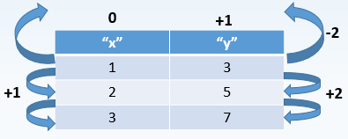

Example 4
Photo world charges $5 for the first enlargement and $2 for each additional enlargement. What is the cost of 15 enlargements?
- Make a Table of Values b) Is this a linear relation? Yes
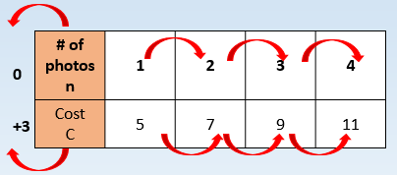
n = +1
C = +2

- Write the expression for the cost in relation to the number of enlargements?

2n check? not true 2n + 3

- What is the cost of 15 enlargements?
C = 2n + 3
C = 2(15) + 3
C = 33 Cost of 15 photos would be $33.

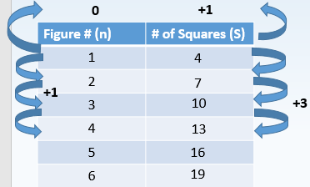
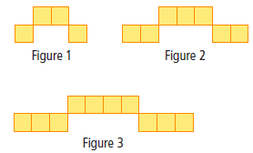
Example 5: a) Make a table of values showing the figure number and the number of squares for the first six figures.

- Write an expression showing the number of squares in terms
of the figure number.
# of squares going up by +3 every time Figure # goes up by +1; therefore 3n 3n + 1

- How many squares would appear in Figure 20?
3n + 1 3(20) + 1 60 + 1 61

