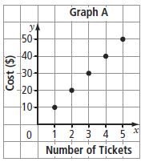
Using a Graph to Create a Table of Values
- Use the following graph to answer questions a-c

- Create a table of values

- Does the graph show a linear relation? How do you know?

- Does it make sense to have values between those on the graph? Explain.

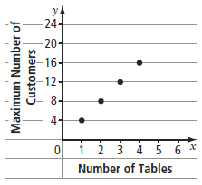
- Use the following graph to answer questions:
- Describe the patterns on the graph.

- Does the graph show a linear relation? Explain

- Complete the table of values for the graph.
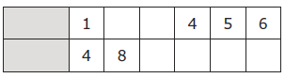

Using an Equation to Create a Table of Values
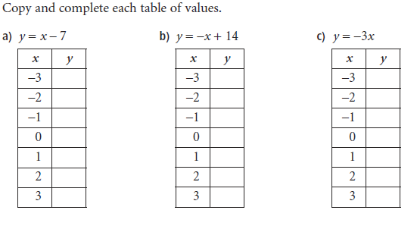

Show work here:

