Linear Graphs – will have a straight line

When the change in the input (x) is constant and the change in the output (y) is constant.
  - We see this in a table where the x and y values go up in a constant manner
  - We see this in a graph that has a straight line

Table with Constant Values Graph with a Straight Line
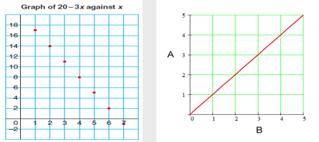
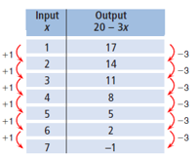

Discrete Data Points vs. Continuous Data

Discrete Data Points
- Only a fixed (finite) # of values is possible and the values can’t be subdivided into parts.
- DO NOT connect the points on a graph
Examples:
- # of books sold – can’t have parts of books
- # of people in class – can’t have parts of people

Continuous Data
- The values can be ANY value within the X and Y range on the graph
- DO connect the points on a graph
Examples:
- Height of students – can be a range of values divided into points (1.82 m, 2.07 m, etc…)
- Time to complete classwork – can be broken down into parts of an hour…

Creating a Table of Values
- The input (x) information is plotted on the horizontal axis. (independent variable)
- The output (y) information is plotted on the vertical axis. (dependent variable)
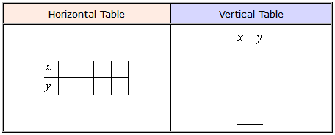
- Choose a variable for each axis (not necessarily x and y) relate this to what the label is on each axis.

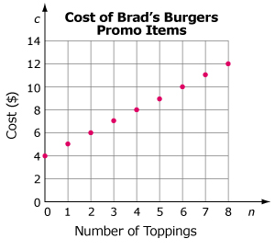
Using a Graph to Create Table of Values

Example 1
n represents the number of topping.
(independent variable)
c represents the cost ($)
(dependent variable)
- What is the cost of Brad’s Burgers with no toppings? $4
- How much is a Brad’s Burgers with 4 toppings? $8
- How much for a burger with 7 topping? $11
- How many topping for $7? 3
- Make a table of values for zero to five toppings
n | C
0 | 4
1 | 5
2 | 6
3 | 7
4 | 8
5 | 9
n | 0 | 1 | 2 | 3 | 4 | 5
C | 4 | 5 | 6 | 7 | 8 | 9

Example 2

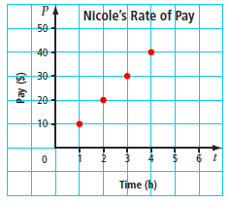
- Make table of values

t | P
1 | 10
2 | 20
3 | 30
4 | 40

- Describe the pattern.

Each hour you multiply by $10

- What is Nicole’s hourly rate of pay?
$\frac{\$10}{1 hour}$

- Is it possible to have points between the ones on the graph?

Yes, Nicole could work 2.5 hours (2 hours 30 minutes)

Example 3
This is called a Coordinate
(1,2)
(2,4)
(3,6)
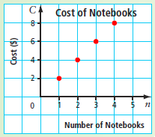
- Make table of values
n | C
1 | 2
2 | 4
3 | 6
4 | 8

- Describe the pattern

each notebook is $2

- What is the cost per notebook?
$\frac{\$2}{1 notebook}$

- Is it possible to have points between the ones on the graph?

No, you cannot buy half or part of a notebook.

Using an Equation to Create Table of Values

Example 1

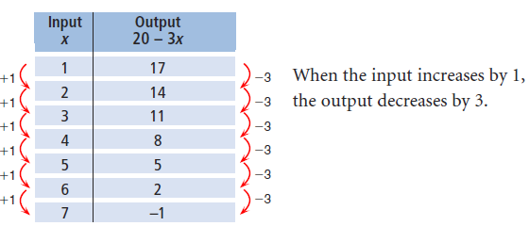
Consider the relation: y is related to 20 – 3x

When x = 1 (input), what is y = ? (output)
- Substitute 1 into 20 – 3x
20 – 3(1)
= 20 – 3
y = 17

When x = 2 (input), what is y = ? (output)
y = 14

When x = 3 (input), what is y = ? (output)
y = 11

Example 2

Kelowna Pizza charges $11 for a medium cheese pizza, plus $2 for each topping.
- Write an equation that relates cost (c) to the number of toppings (n).

Hint: c = 11 + 2n

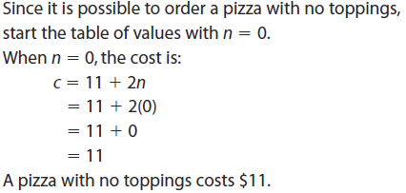

b) Use the equation to create a table of values.
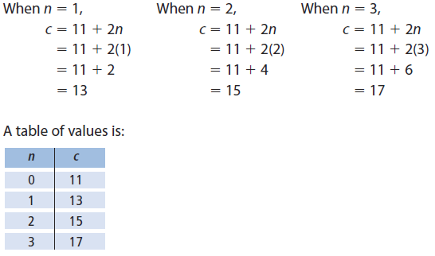
- What is the cost of the pizza with 5 toppings?
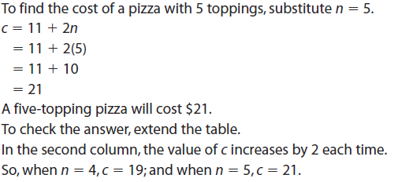
- How many toppings are on a pizza that costs $27?
