The circulatory system uses blood vessels to carry oxygen to the cells and picks up carbon dioxide to be eliminated from the body

There are two types of systems utilized by multicellular organisms:
  - Open system: blood carrying oxygen and nutrients is pumped into body cavities where it bathes the cells. The heart relaxes and blood is taken back to the heart through open ended pores. (ex. snail, clam)
  - Closed system: blood is contained within blood vessels moving to and from the heart. (ex. worm, human)

- Arteries: blood vessels that carry blood away from the heart have thick muscular walls
- Veins: blood vessels that carry blood back to the heart have valves so that the blood only flows one way
- Capillaries: small blood vessels that connect arteries and veins
  - so small that blood cells must travel single file

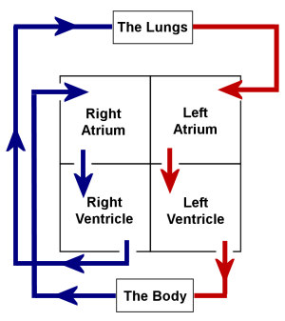
The heart contains 4 sets of valves that operate as one-way doors (keep blood flowing in one direction in the heart)
- valves closing makes “lubb” heart sound
- when ventricles relax some gives the “dubb” heart sound

