Remember: Multiplication is just a quick way of adding
- 3 x 5 really means 3 + 3 + 3 + 3 +3
- Add: 3 + 3 + 3 + 3 + 3 you get 15
- So: 3 x 5 also equals 15

Helpful Rules:
Rule / Description | Example
You Times Me is the Same as Me Times You  - known as the reflexive property of multiplication, just means that A x B = B x A | 6 x 7 = 42  7 x 6 = 42
0's: Anything times 0 equals 0 | 0 x 2 = 0
1’s: Any number times 1 is that number | 1 x 6 = 6  1 x 4 = 4
2’s: Multiply by 2, Double the number | 2 x 5 = 10  2 x 10 = 20
4’s: Multiplying by 4 is doubling twice | 4 x 3  3 + 3 = 6, 6 +6 = 12
5's: Use what you know about skip counting by 5 | 5 x 3 = 15  (5, 10, 15)
6’s: Multiply 6 by an even number, they both end in the same digit | 6 x 2 = 12  6 x 4 = 24
9's: 10 times the number then minus the number | 9 x 4 = 36  10 x 4 = 40 – 4 = 36
10's: Add a zero to any number that you multiply by 10. | 6 x 10 = 60
11's: just repeat the digit | 4 x 11 = 44

Only 10 Problems Are Left to Memorize

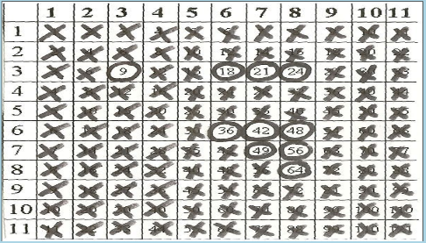
Other Tricks & Rhymes

5,6,7,8 56 = 7 x 8
7 x 8 is full of tricks, 7 x 8 is 56
7 x 7: 7 and 7 are doing fine, 7 time 7 is 49
8 time 8 fell on the floor, picked it up was 64 3 x 7 is lots of fun, 3 x 7 is 21

9’s: Fingers numbered 1 through 10, fold down number multiplied by and you have your answer
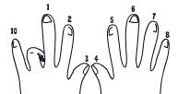2 x 9 = 18

11’s: for 10x11 to 18x11: write the sum of the digits between the digits

15 x 11: 1 (1+5) 5 = 165 13 x 11: 1 (1+3) 3 = 143

In your groups come up with a rhyme or trick for the other multiplication facts:
3x3:
3x6:
3x8:
6x6:
6x7:
6x8:

