Continental Drift – 1st proposed by Alfred Wegener in 1915
- Supercontinent Pangaea started to break up about 220 million years ago.
- “pan” means all; “gaea” means earth

Earth Composition – Inner Core, Outer Core, Mantle, Crust
- the “Lithosphere” contains the earth’s crust and the uppermost part of the upper mantle.
- “Asthenosphere” - A partly MOLTEN layer of the upper mantle

There are 7 major plates and 5 minor plates – 12 plates total.
The plates move approximately 1 inch per year ~ 2cm
- plates move due magma convection currents in the Asthenosphere (upper mantle)

HOT SPOT - is a geological area where molten rock rises to Earth’s surface! ex. Hawaii Islands

3 Types of plate Boundaries

- Diverging Plates
- In Ocean - “Spreading Centers” – Mid-Atlantic Ridge
- On Land – “Rift Valleys” are areas of the Earth’s surface where splits apart

- Converging Plates (3 types)
- Oceanic - Continental Plate Convergence
Oceanic plate is denser and dives under the continental plates
- causes volcanic belts and earthquakes

- Oceanic - Oceanic Plate Convergence…
The denser plate subducts under the other, a deep ocean trench is formed, and the subducting plate sinks deep into the mantle
- causes volcanic island arc ( ie. Japan islands and Aleutian island in Alaska) and earthquakes

- Continental - Continental Plate Convergence…
When continental plates collide, subduction DOES NOT occur because the plates are the same density. - forming great Mountain ranges ( ie. The Himalayas)

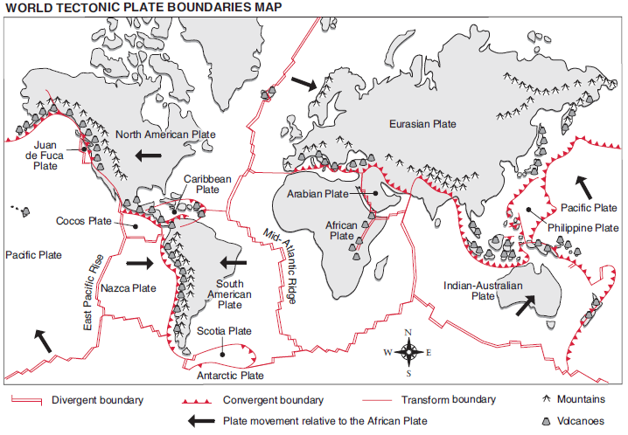
- Transform Plates – is when a plates slide past each – no volcano or mountains form, earthquakes

Earthquakes - ~95% of all earthquakes occur along plate boundaries
80% of the world’s earthquakes occur in a ring that borders the pacific ocean - Ring of Fire

An Earthquake starts at a location inside the Earth called a “focus” (foci)
The “epicentre” is the point on the EARTH’s SURFACE directly above the focus.

SEISMIC WAVES - are the vibrations (waves) of energy released by a quake!
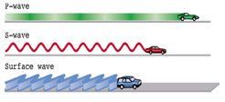
Primary-wave:
- Fastest
-Side to side motion
(These make the sound that we hear)

Secondary-wave:
-S for “secondary”
-Up/down motion

Surface waves:
-Slowest
-Travel only on ground (or water) surface
-Damaging to structures
-Circle Motion
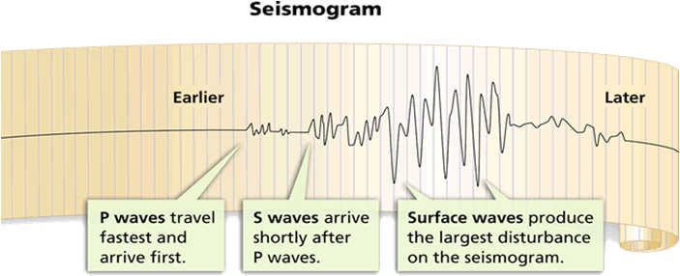
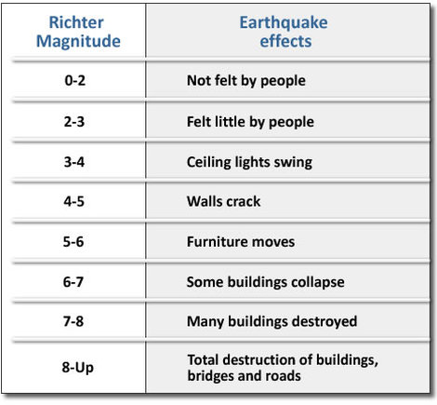

The Richter's magnitude scale is for measuring the strength
("size") of earthquakes

Volcanoes
- Composite Volcano – Mt. St. Helens (cone-shaped)
- Found along plate boundaries, usually by subduction zones
- Layers of ash and thick lava form a tall cone.
- As magma reaches the surface, it cools, hardens, and traps gases below.
- Pressure builds; eventually, there is an eruption.

2) Shield Volcano (Hawaii Island,Yellowstone, largest type)
- these are not found at plate boundaries but instead form over hot spots.
- Thin magma/lava flows out from a hot spot and forms a low, wide cone.

3) Rift eruptions - occur at rifts and ridges (diverging plate, cracks in lithosphere)
- fountains of lava, Not very destructive or violent

